Real-World IQ Dataset for Automatic Radio Modulation Recognition under Multipath Channels
Nikolay Yu. Belousov¹* and Mikhail V. Ronkin¹
1 Institute of Radioelectronics and Information Technologies, Ural Federal University named after the First President of Russia B. N. Yeltsin, Yekaterinburg, Russia

*Corresponding author: Nikolai.Belousov@urfu.ru

Received: January 20, 2026; Revised: January 20, 2026; Accepted: January 20, 2026; Published online: January 21, 2026

Abstract: Automatic modulation recognition (AMR) is essential for modern wireless communication systems, cognitive radio, and spectrum monitoring applications. Despite numerous synthetic datasets, real-world datasets capturing both clean and multipath propagation conditions remain scarce. This study presents a comprehensive real-world IQ dataset comprising seven modulation types (BPSK, QPSK, QAM, GMSK, OFDM, NBFM, WBFM) recorded at 2.4 GHz under controlled signal-to-noise ratio (SNR) conditions (20–30 dB) using software-defined radio (SDR) hardware. Signals were captured under both line-of-sight and multipath channel conditions to reflect realistic wireless environments. The dataset contains over 6 million IQ frames segmented into fixed-length sequences of 1024 samples, power-normalized, and stored in HDF5 format with complete metadata annotations. To demonstrate the dataset's utility, we trained a baseline 1D convolutional neural network (CNN) achieving 84.3% test accuracy. The dataset is publicly available on Mendeley Data and provides a reproducible benchmark for evaluating AMR algorithms under realistic channel impairments.
Keywords: automatic modulation recognition; dataset; software-defined radio; multipath propagation; deep learning; convolutional neural networks

INTRODUCTION

Automatic modulation recognition (AMR) plays a critical role in modern wireless communication systems, enabling cognitive radio [1], spectrum monitoring [2], and intelligent signal processing [3]. Traditional AMR approaches rely on likelihood-based methods and expert-designed features [4], which often struggle under low signal-to-noise ratio (SNR) conditions and channel impairments such as multipath fading. Recent advances in deep learning have demonstrated superior performance in AMR tasks by learning discriminative features directly from raw in-phase and quadrature (IQ) samples [5-7].

Despite the proliferation of deep learning-based AMR methods, most existing studies rely on synthetic datasets generated through mathematical simulation [8-10]. While such datasets offer precise control over signal parameters, they fail to capture real-world hardware imperfections, environmental noise, and realistic propagation effects. This discrepancy between simulated training conditions and real-world deployment scenarios can significantly degrade model performance [11]. Few publicly available datasets incorporate real SDR-captured signals, and even fewer account for multipath propagation—a dominant impairment in urban and indoor wireless environments [12].

Multipath propagation occurs when radio signals reflect off obstacles and arrive at the receiver via multiple paths with varying delays and attenuations. This phenomenon causes intersymbol interference (ISI), signal fading, and phase distortions, severely degrading modulation classification accuracy [13]. Existing AMR datasets either neglect multipath effects entirely or simulate them using oversimplified channel models [14]. Consequently, there is an urgent need for real-world datasets that authentically represent both clean and impaired channel conditions.

To address this gap, we present a comprehensive real-world IQ dataset for AMR, captured using HackRF One SDR transceivers operating at 2.4 GHz. The dataset encompasses seven widely used modulation schemes: binary phase shift keying (BPSK), quadrature phase shift keying (QPSK), quadrature amplitude modulation (QAM), Gaussian minimum shift keying (GMSK), orthogonal frequency-division multiplexing (OFDM), narrowband frequency modulation (NBFM), and wideband frequency modulation (WBFM). For each modulation type, signals were recorded under six SNR levels (20, 22, 24, 26, 28, 30 dB) and two propagation conditions: clean (direct line-of-sight) and multipath (using GNU Radio's channel model block with controlled tap delays and attenuations).

The main contributions of this work are as follows:

Real-world data acquisition: Unlike purely synthetic datasets, our signals were transmitted and received using actual SDR hardware, capturing authentic RF impairments including clock jitter, phase noise, and hardware nonlinearities.

Controlled multipath modeling: We systematically introduce multipath effects using a validated channel model with three propagation paths, enabling reproducible evaluation of AMR robustness under fading conditions.

Comprehensive annotation: Each IQ frame is annotated with modulation type, channel condition (clean/multipath), and SNR value, facilitating fine-grained analysis of classification performance across different scenarios.

Public availability and reproducibility: The complete dataset (over 6 million IQ frames), preprocessing scripts, and baseline CNN implementation are publicly released on Mendeley Data, promoting reproducible research and fair algorithm comparison.

Baseline benchmarking: We provide baseline classification results using a 1D-CNN architecture, achieving 84.3% test accuracy and offering performance analysis across SNR levels and channel types.

The remainder of this paper is organized as follows. Section II reviews related work on AMR datasets and methods. Section III describes the experimental setup, signal generation, data acquisition, and preprocessing pipeline. Section IV presents the dataset characteristics, baseline model architecture, and experimental results. Section V discusses the implications, limitations, and potential applications of the dataset. Section VI concludes the paper and outlines future research directions.

MATERIALS AND METHODS

Experimental Equipment

The data acquisition system consisted of two HackRF One SDR transceivers: one original device (Great Scott Gadgets, USA) and one compatible clone. Both units operate across the frequency range of 1 MHz to 6 GHz with 8-bit ADC/DAC resolution and support up to 20 MHz instantaneous bandwidth [15]. While the clone exhibited reduced output power and sensitivity at frequencies above 5 GHz, performance at 2.4 GHz was comparable to the original unit for our experimental requirements.

Each SDR was equipped with omnidirectional Wi-Fi antennas (gain: 5 dBi, dual-band 2.4/5 GHz) featuring adjustable tilt angles and RP-SMA connectors. The transmitter and receiver were positioned in an indoor laboratory environment at a fixed separation distance of approximately 3 meters to ensure sufficient signal strength while allowing realistic multipath reflections from walls, furniture, and laboratory equipment.

Signal Generation and Transmission

Signal generation was performed using GNU Radio Companion (GRC) version 3.8, an open-source software framework for SDR development [16]. Separate flowgraphs were designed for each modulation type, incorporating standard GNU Radio blocks for modulation, filtering, and pulse shaping. Key parameters for each modulation scheme are summarized in Table 1.
Table 1. Signal generation parameters for each modulation type
Modulation | Symbol Rate (kSps) | Samples per Symbol | Pulse Shaping Filter | Additional Parameters
BPSK | 100 | 4 | Root Raised Cosine (α=0.35) | Differential encoding: off
QPSK | 100 | 4 | Root Raised Cosine (α=0.35) | Gray coding: enabled
QAM | 100 | 4 | Root Raised Cosine (α=0.35) | Constellation: 16-QAM
GMSK | 100 | 4 | Gaussian (BT=0.3) | -
OFDM | - | - | - | FFT size: 64, CP length: 16, Occupied tones: 48
NBFM | - | - | - | Audio bandwidth: 3 kHz, Deviation: 5 kHz
WBFM | - | - | - | Audio bandwidth: 15 kHz, Deviation: 75 kHz

For analog modulations (NBFM, WBFM), the baseband audio signal was generated using a combination of sine wave sources at multiple frequencies to simulate voice-like spectral content. All signals were upsampled to a common sample rate of 2 MSps before transmission to maintain consistent time-frequency characteristics across modulation types.

Channel Modeling and SNR Control
Two propagation scenarios were implemented:
- Clean channel (line-of-sight): Signals were transmitted directly without additional impairments beyond ambient noise and hardware nonlinearities.
- Multipath channel: A three-tap channel model was implemented in GNU Radio using the Channel Model block with the following impulse response:
$$h\left[n\right]= \left.\left[1.0 + 0j,; 0.7 - 0.2j,; 0.3 - 0.1j\right.\right]$$
where the first tap represents the direct path, and subsequent taps model delayed, attenuated reflections with phase shifts. Tap delays were set to [0μs, 100μs, 200μs], corresponding to path length differences typical of indoor environments.
SNR was controlled by adding calibrated additive white Gaussian noise (AWGN) using the Channel Model block's noise voltage parameter. For a target SNR in dB, the noise voltage $σ_{n}$ was calculated as:
$$σ_{n}= \frac{1}{\sqrt{{10}^{\left\{\frac{SNR_{\left\{dB\right\}}}{10}\right\}}}}$$
assuming unit signal power after normalization. Six SNR levels were used: 20, 22, 24, 26, 28, and 30 dB, covering a range from moderate to high SNR conditions commonly encountered in practical wireless systems.

Data Acquisition and Recording

The receiving SDR was connected to a separate computer running GNU Radio, configured to capture complex baseband samples at 2 MSps and store them as raw binary files (complex64 format). Each recording session lasted several minutes, generating continuous IQ streams for each combination of:

Modulation type (7 types)

SNR level (6 levels)

Channel condition (2 conditions: clean and multipath)

This resulted in a total of 7 × 6 × 2 = 84 unique signal configurations. File naming followed a systematic convention: {MODULATION}_{ref}_{SNR}.dat, where {MODULATION} indicates the modulation type (e.g., BPSK, QPSK), the optional _ref suffix denotes clean (reference) channel recordings, and {SNR} specifies the SNR value in dB.

Data Preprocessing and Segmentation

Raw binary IQ files were processed using custom Python scripts to extract, normalize, and structure the data for machine learning applications. The preprocessing pipeline consisted of the following stages:

File parsing and validation: Each .dat file was read as a NumPy array of complex64 samples. Modulation type, SNR, and channel condition were extracted from the filename using regular expression pattern matching.

Frame segmentation: Continuous IQ streams were segmented into fixed-length frames of 1024 samples. This frame length was chosen to balance temporal context (sufficient for capturing modulation patterns) and computational efficiency during training.

Power normalization: To eliminate amplitude variations caused by different SNR levels and transmission power settings, each frame was individually normalized by its average signal power:

$$x_{norm}=\frac{x}{\sqrt{\frac{1}{N}\sum_{n=1}^{N}{{\left|x\left[n\right]\right|}^{2}+ϵ}}}$$

where $x$ is the original IQ frame, $N = 1024$ is the frame length, and $ϵ={10}^{-12}$ prevents division by zero.

Format conversion: Normalized IQ frames were converted to two-channel format, separating in-phase (I) and quadrature (Q) components, resulting in arrays of shape (1024, 2). Data were stored in float16 precision to reduce storage requirements while maintaining sufficient numerical precision.

HDF5 storage: All frames were stored in a single HDF5 file with the following datasets:

X: IQ frames, shape (N_frames, 1024, 2), dtype float16

y_mod: modulation class labels, shape (N_frames,), dtype int16

y_chan: channel type labels (0=clean, 1=multipath), shape (N_frames,), dtype int8

y_snr: SNR values in dB, shape (N_frames,), dtype int16

Metadata including frame length, modulation class mappings (JSON format), and SNR values were stored as HDF5 attributes.

Dataset Balancing and Splitting

To ensure unbiased model training and evaluation, the dataset was balanced across all combinations of modulation type, channel condition, and SNR level. From each of the 84 signal configurations, 10,000 frames were randomly sampled, yielding a total of 840,000 balanced frames. This balanced subset was then split into training (70%), validation (15%), and test (15%) subsets using stratified random sampling to maintain equal representation of all classes in each partition.

The final dataset composition is:

Training set: 588,000 frames

Validation set: 126,000 frames

Test set: 126,000 frames

These subsets were saved as separate HDF5 files (subset_train.h5, subset_val.h5, subset_test.h5) for convenient loading during experiments.

Baseline Model Architecture

To demonstrate the dataset's utility for AMR tasks, we implemented a baseline one-dimensional convolutional neural network (1D-CNN) using TensorFlow 2.x. The network architecture consists of three convolutional blocks followed by global average pooling and a fully connected classification head:

Input layer: (1024, 2) - normalized IQ frame

Conv1D block 1: 64 filters, kernel size 7, padding=same → Batch Normalization → ReLU → MaxPooling (pool size 2)

Conv1D block 2: 128 filters, kernel size 5, padding=same → Batch Normalization → ReLU → MaxPooling (pool size 2)

Conv1D block 3: 256 filters, kernel size 3, padding=same → Batch Normalization → ReLU → MaxPooling (pool size 2)

Global Average Pooling: reduces spatial dimension to single vector

Dense layer: 256 units, ReLU activation

Dropout: rate 0.3

Output layer: 7 units (one per modulation class), softmax activation

The model was trained using the Adam optimizer with an initial learning rate of 0.001, categorical cross-entropy loss, and a batch size of 512. Training was conducted on CPU for 15 epochs with the following callbacks:

ModelCheckpoint: save best model based on validation accuracy

ReduceLROnPlateau: reduce learning rate by factor of 0.5 if validation loss plateaus for 2 epochs

EarlyStopping: stop training if validation accuracy does not improve for 5 consecutive epochs

Evaluation Metrics

Model performance was assessed using the following metrics:

Overall test accuracy: fraction of correctly classified frames across all modulation types

Per-SNR accuracy: classification accuracy computed separately for each SNR level to evaluate robustness to noise

Per-channel accuracy: accuracy for clean versus multipath conditions to assess resilience to channel impairments

Confusion matrix: visualization of per-class classification errors

Statistical analysis and visualization were performed using Python libraries including NumPy, Matplotlib, and scikit-learn.

RESULTS

Dataset Characteristics
The final balanced dataset comprises 840,000 IQ frames distributed uniformly across 7 modulation types, 6 SNR levels, and 2 channel conditions, with 10,000 frames per unique configuration. Table 2 summarizes the complete dataset structure.
Table 2. Dataset composition
Parameter | Value
Carrier frequency | 2.4 GHz
Sampling rate | 2 MSps
Frame length | 1024 samples
Number of modulation types | 7 (BPSK, QPSK, QAM, GMSK, OFDM, NBFM, WBFM)
SNR levels (dB) | 20, 22, 24, 26, 28, 30
Channel conditions | Clean (line-of-sight), Multipath
Total frames (before balancing) | 6,037,361
Total frames (balanced subset) | 840,000
Training frames | 588,000
Validation frames | 126,000
Test frames | 126,000
Storage format | HDF5
Data type | float16 (IQ frames), int16 (labels)
The dataset is publicly available on Mendeley Data under the title "Real-World IQ Dataset for Automatic Radio Modulation Recognition under Multipath Channels" [17].

Baseline Classification Performance
The baseline 1D-CNN achieved an overall test accuracy of 84.3% across all modulation types, channel conditions, and SNR levels. This demonstrates that the dataset provides sufficient discriminative information for modulation recognition despite the presence of realistic hardware impairments and multipath effects.
Table 3. Test set performance metrics
Metric | Value
Overall accuracy | 84.3%
Training time (15 epochs, CPU) | ~10 hours
Number of model parameters | ~210,000

Accuracy vs. Signal-to-Noise Ratio

Classification accuracy varied with SNR level, as shown in Fig. 1. Performance improved monotonically with increasing SNR, reaching a peak at 28 dB (85.8%). Interestingly, accuracy at 30 dB (84.6%) was slightly lower than at 28 dB, possibly due to sampling variability or subtle overfitting to mid-range SNR conditions during training. The lowest accuracy (83.0%) occurred at 24 dB, representing the most challenging noise condition in our dataset.

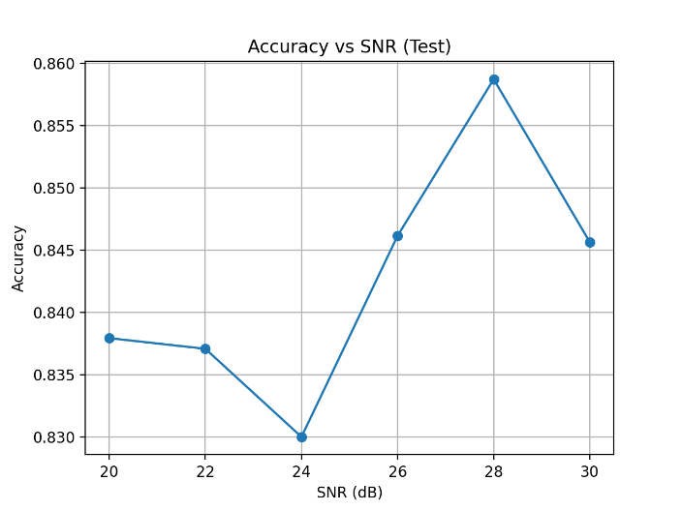

Fig. 1. Classification accuracy as a function of SNR on the test set. Accuracy ranges from 83.0% at 24 dB SNR to 85.8% at 28 dB SNR, demonstrating robustness across moderate to high SNR conditions.

(Insert figure showing SNR (dB) on x-axis vs. Accuracy on y-axis)

Accuracy under Clean vs. Multipath Conditions

Fig. 2 compares classification performance under clean (line-of-sight) and multipath propagation conditions. Clean channel signals achieved 85.7% accuracy, while multipath signals achieved 82.9% accuracy. This modest 2.8 percentage point degradation indicates that the CNN learned relatively robust features capable of tolerating multipath-induced ISI and fading, though some performance loss is inevitable under channel impairments.

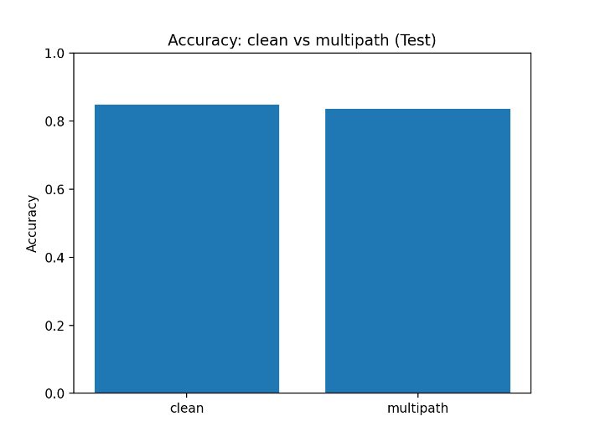

Fig. 2. Comparison of classification accuracy for clean (line-of-sight) and multipath channel conditions. Multipath propagation causes a moderate degradation of ~3% in classification accuracy.

(Insert bar chart showing two bars: "clean" and "multipath")

Confusion Matrix Analysis

The confusion matrix (Fig. 3) reveals per-class classification patterns. Diagonal elements indicate correct classifications, while off-diagonal elements represent confusion between modulation types.

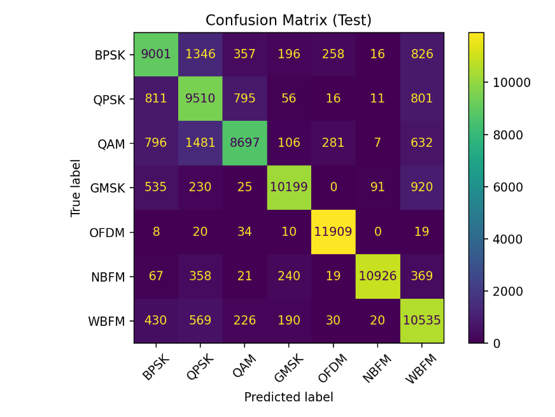

Fig. 3. Confusion matrix for the test set, showing per-class classification performance. Rows represent true labels, columns represent predicted labels.

(Insert confusion matrix heatmap)

Key observations:

OFDM exhibited the highest classification accuracy (>95%), likely due to its distinctive spectral structure with multiple orthogonal subcarriers.

NBFM and WBFM achieved high accuracy (>92%), benefiting from characteristic frequency-domain features.

BPSK, QPSK, and QAM showed moderate inter-class confusion, particularly at lower SNR levels, as their constellation structures share similarities when corrupted by noise and multipath.

GMSK demonstrated robust recognition (>89%), aided by its constant-envelope property and Gaussian pulse shaping.

Counts

Frame-Level SNR Verification

To verify the effectiveness of SNR control during data acquisition, we estimated the empirical SNR of randomly sampled test frames and compared it with the target SNR values. The results confirmed close agreement with the intended SNR levels, with deviations typically below 0.5 dB across all configurations, validating the reliability of the AWGN-based SNR control procedure.

DISCUSSION

This work presents the first publicly available real-world IQ dataset for AMR that systematically incorporates multipath propagation effects alongside clean channel conditions across multiple SNR levels. Our dataset addresses critical limitations of existing synthetic datasets [8-10] by capturing authentic RF hardware impairments, environmental noise, and realistic propagation phenomena.

The baseline CNN's 84.3% overall accuracy demonstrates that the dataset provides sufficient complexity and realism to serve as a meaningful benchmark for AMR algorithm development. The performance degradation from clean (85.7%) to multipath (82.9%) conditions underscores the practical importance of training on datasets that reflect real-world channel impairments. Models trained exclusively on clean simulated signals risk significant performance loss when deployed in actual wireless environments [11].

Our SNR-dependent accuracy analysis (Fig. 1) reveals a performance plateau above 26 dB, suggesting that the primary limiting factor shifts from noise to other impairments (multipath, hardware nonlinearities) at higher SNR levels. This observation highlights the value of our dataset's multipath component: even at high SNR, channel effects remain challenging for modulation classifiers.

The confusion matrix (Fig. 3) indicates that structurally similar modulations (BPSK/QPSK/QAM) are more prone to misclassification, consistent with prior work [18]. Conversely, OFDM's exceptional recognizability stems from its unique multi-carrier spectral signature, suggesting that frequency-domain features may warrant greater emphasis in future model designs. The strong performance on frequency modulations (NBFM/WBFM) confirms that analog modulations remain distinguishable even under realistic channel conditions, an important consideration for spectrum monitoring applications that must detect legacy analog transmissions.

Limitations and Future Work

Several limitations should be acknowledged:

Frequency range: Signals were captured only at 2.4 GHz. Future work should extend the dataset to additional frequency bands (e.g., sub-1 GHz, 5 GHz) to assess frequency-dependent propagation effects.

Channel model complexity: While our three-tap model captures essential multipath characteristics, real-world channels exhibit time-varying fading and Doppler effects. Future datasets could incorporate mobile scenarios and fading channel models (e.g., Rayleigh, Rician).

Modulation set: The seven modulation types cover common analog and digital schemes, but emerging waveforms (e.g., GFDM, FBMC, advanced MIMO schemes) are not included.

Baseline model: Our 1D-CNN serves as a starting point, but more sophisticated architectures (ResNets, Transformers, complex-valued networks) may yield improved performance.

Real-time deployment: The dataset consists of offline recordings. Future work should validate model performance on truly real-time streaming data with minimal latency.

Despite these limitations, the dataset provides a valuable resource for reproducible AMR research. By releasing the complete data, preprocessing scripts, and baseline implementation, we enable the community to develop and fairly compare novel algorithms under standardized conditions.

Practical Applications

The dataset supports multiple application scenarios:

Cognitive radio: Dynamic spectrum access systems require rapid, accurate modulation recognition to identify vacant channels and coexisting transmitters.

Spectrum monitoring: Regulatory agencies and network operators can deploy AMR systems to detect unauthorized or interfering transmissions.

Military and security: Signal intelligence applications benefit from robust modulation classifiers capable of operating under adverse channel conditions.

Education and benchmarking: The dataset provides a realistic testbed for teaching machine learning in wireless communications and establishing fair performance comparisons across published methods.

CONCLUSIONS
We presented a comprehensive real-world IQ dataset for automatic modulation recognition, comprising seven modulation types recorded at 2.4 GHz under controlled SNR conditions (20–30 dB) and both clean and multipath propagation scenarios. The dataset contains 840,000 balanced, power-normalized IQ frames of 1024 samples each, annotated with modulation type, channel condition, and SNR level. A baseline 1D-CNN achieved 84.3% test accuracy, with performance degradation of approximately 3% under multipath conditions compared to clean channels.
This dataset addresses a critical gap in the AMR research community by providing authentic, hardware-captured signals that reflect realistic propagation impairments. The public release of data, code, and baseline results on Mendeley Data enables reproducible research and fair algorithmic comparisons. Future work will expand the dataset to additional frequencies, more complex channel models, and emerging modulation schemes, further advancing the state of the art in robust automatic modulation recognition.

Conflict of interest disclosure: The authors declare no conflict of interest.
Data availability: The dataset is publicly available on Mendeley Data at 10.17632/tjzsbph49x.1.

REFERENCES
- Mitola J, Maguire GQ. Cognitive radio: making software radios more personal. IEEE Pers Commun. 1999;6(4):13-18.
- Akyildiz IF, Lee WY, Vuran MC, Mohanty S. NeXt generation/dynamic spectrum access/cognitive radio wireless networks: a survey. Comput Netw. 2006;50(13):2127-59.
- O'Shea TJ, Corgan J, Clancy TC. Convolutional radio modulation recognition networks. In: Engineering Applications of Neural Networks: 17th International Conference, EANN 2016; 2016 Sep 2-5; Aberdeen, UK. Springer; 2016. p. 213-26.
- Dobre OA, Abdi A, Bar-Ness Y, Su W. Survey of automatic modulation classification techniques: classical approaches and new trends. IET Commun. 2007;1(2):137-56.
- O'Shea TJ, Roy T, Clancy TC. Over-the-air deep learning based radio signal classification. IEEE J Sel Top Signal Process. 2018;12(1):168-79.
- West NE, O'Shea T. Deep architectures for modulation recognition. In: 2017 IEEE International Symposium on Dynamic Spectrum Access Networks (DySPAN); 2017 Mar 6-9; Baltimore, MD, USA. IEEE; 2017. p. 1-6.
- Zhang D, Ding W, Zhang B, Xie C, Li H, Liu C, Han J. Automatic modulation classification based on deep learning for unmanned aerial vehicles. Sensors. 2018;18(3):924.
- O'Shea TJ, Corgan J, Clancy TC. Dataset: RML2016.10a [Internet]. DeepSig Inc.; 2016 [cited 2026 Jan 15]. Available from: Datasets - DeepSig
- Hauser SC, Headley WC, Michaels AJ. Signal detection effects on deep neural networks utilizing raw IQ for modulation classification. In: MILCOM 2017 - 2017 IEEE Military Communications Conference; 2017 Oct 29-Nov 2; Baltimore, MD, USA. IEEE; 2017. p. 121-7.
- Huynh-The T, Hua CH, Pham QV, Kim DS. MCNet: An efficient CNN architecture for robust automatic modulation classification. IEEE Commun Lett. 2020;24(4):811-15.
- Flowers B, Buehrer RM, Headley WC. Evaluating adversarial evasion attacks in the context of wireless communications. IEEE Trans Inf Forensics Security. 2020;15:1102-13.
- Molisch AF. Wireless communications. 2nd ed. Chichester: Wiley-IEEE Press; 2011.
- Goldsmith A. Wireless communications. Cambridge: Cambridge University Press; 2005.
- Ramjee Prasad. OFDM for wireless communications systems. Boston: Artech House; 2004.
- HackRF One [Internet]. Great Scott Gadgets; c2024 [cited 2026 Jan 15]. Available from: HackRF One - Great Scott Gadgets
- GNU Radio [Internet]. GNU Radio Project; c2024 [cited 2026 Jan 15]. Available from: https://www.gnuradio.org/
- Belousov NYu, Ronkin MV. Real-World IQ Dataset for Automatic Radio Modulation Recognition under Multipath Channels. Mendeley Data. 2026. DOI: 10.17632/tjzsbph49x.1
- Eldemerdash YA, Dobre OA, Öner M. Signal identification for multiple-antenna wireless systems: Achievements and challenges. IEEE Commun Surv Tutor. 2016;18(3):1524-51.

